Civil war in Liberia

UNSC Resolution: | 1041
Date of adoption: | 29-Jan-1996
Operative paragraph: | 6
Demand number: | 1041,0611

Sarah-Myriam Martin-Brûlé

Wording of demand

strictly respect the status of ECOMOG and UNOMIL personnel, as well as organizations and agencies delivering humanitarian assistance throughout Liberia, and further demands that these factions facilitate such deliveries and that they strictly abide by the relevant rules of international humanitarian law

List of addressees of the demand

National Patriotic Front of Liberia, Government of Liberia, Central Revolutionary Council of the National Patriotic Front of Liberia, Lola Defence Force, Liberian National Conference, Liberian Peace Council, United Liberation Movement of Liberia for Democracy - Krahn, United Liberation Movement of Liberia for Democracy - Mandingo

Short-term compliance

Description of the addressee(s)’ conduct

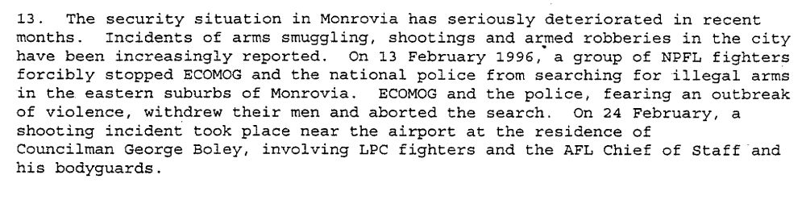
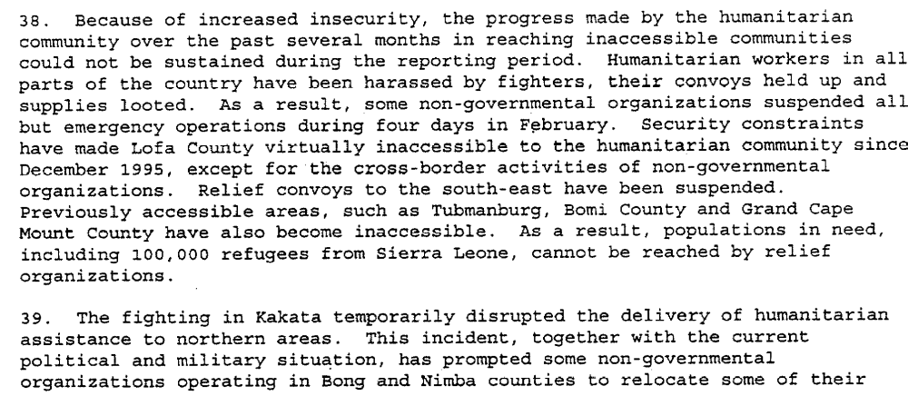
Sixteenth Progress Report of the Secretary-General on the United Nations Observer Mission in Liberia, S/1996/232, 1 April 1996.

“By a letter dated 19 April 1996, addressed to the President of the Security
Council, the Secretary-General described the widespread looting and complete
breakdown of law and order since the eruption of fighting in Monrovia on 6 April 1996.
Given the security situation, civilian and military non-essential personnel of UNOMIL,
United Nations agencies and non-governmental organizations had been relocated to
neighbouring countries. Thousands of people had been displaced and were living in
desperate conditions. He stressed that those developments had clearly demonstrated that
ECOMOG’s “chronic” lack of manpower and logistics had seriously undermined its
operational effectiveness.”
(...)
“On 21 May 1996, pursuant to resolution 1041 (1996), the Secretary-General
submitted to the Council his seventeenth progress report on UNOMIL, describing
developments in Liberia, and containing his recommend ations on the future role of the
Observer Mission. 27 The Secretary-General reported that renewed hostilities had
continued and were seriously jeopardizing the peace process, and the security situation in
Monrovia remained dangerous and unpredictable. Over the previous six weeks, faction
leaders had shown wanton disrespect for the United Nations, ECOWAS and the
international community, as well as disregard for the Liberian people’s desire for peace.
ECOWAS had agreed on steps to resume the implementation of the Abuja Agreement,
but warned the faction leaders that if they failed to implement the measures agreed upon,
it would reconsider its involvement in Liberia. He underscored that the withdrawal of
ECOMOG could be catastrophic, not only for the country but for the whole subregion.
Moreover, should the Monitoring Group be compelled to withdraw, UNOMIL would be
forced to do the same. The Secretary-General stated that UNOMIL continued to play an
important role in Liberia and therefore recommended a three-month extension of its
mandate, until 31 August 1996. The willingness of the faction leaders to engage in
genuine negotiations would be an important factor in determining further involvement of
the international community in Liberia.”
(...)
“They had reignited violence; turned Monrovia from a safe haven into a war zone; and looted the equipment of relief agencies. Notwithstanding that situation, the international community needed to remain engaged in the efforts to provide relief and to bring peace to the people of Liberia. He expressed his country’s belief that the Security Council needed to support the important initiative by the countries of the region. His delegation would support the extension of the mandate of UNOMIL, however it urged all Liberians, particularly the faction leaders, to use that time to meet the conditions ECOWAS had laid out and to offer their people the chance for peace.”
Chapter 8, “The Situation in Liberia”
http://www.un.org/en/sc/repertoire/96-99/CHAPTER%208/African/02%20-%20Liberia.pdf

Assessment

Short-term compliance
X No or marginal compliance (1) | Medium low compliance (2) | Medium high compliance (3) | Full or almost full compliance (4)

Considerations underlying the assessment

Within the six months following the adoption of the resolution, the demand addressees violated all the elements mentioned in the above operative paragraph (did not strictly respect the status of ECOMOG and UNOMIL personnel, organizations and agencies delivering humanitarian assistance throughout Liberia, and impeded their deliveries and violated the rules of international humanitarian law).
.

Medium-term compliance

Description of the addressee(s)’ conduct

In 1997:
“Following the completion of the disarmament and demobilization exercise and the deployment of ECOMOG to most parts of the country, relief organizations were able to operate in all 13 counties of Liberia.”
UNOMIL, Liberia, Background
http://www.un.org/Depts/dpko/dpko/co_mission/unomilFT.htm#DECEMBER

Assessment

Medium-term compliance
No or marginal compliance (1) | Medium low compliance (2) | X Medium high compliance (3) | Full or almost full compliance (4)

Considerations underlying the assessment

Within the two years following the adoption of the resolution, the demand addressees abide by most elements of the demand (respect peacekeeping and humanitarian personnel, facilitated the delivery of relief and decreased their violation of humanitarian law).

Depth of demand

Assessment

Level of depth of demand
X Low depth of demand (1) | Medium depth of demand (2) | High depth of demand (3)

Considerations underlying the assessment

At that point in the peace process, this was a low depth demand i.e. compliance with this demand did not put the survival of the demand addressees at a significant risk nor did it impact their chances to win victory or to win power in the aftermath.

Level of confidence about coding decisions

Level of confidence about coding decision
Extremely high | High | X Moderate

Comments to IPI (if any)

